6 High-Level Design (Architecture)
Chapter 8. The rule now reverses: a high-level design that does not say where things run, what they are built from and what that choice cost has not been done.
6.1 Architectural drivers: quality-attribute scenarios
QAS | Quality  attribute | Stimulus | Artifact | Response | Response  measure | From
QAS-01 | Performance | Search of a database with no more than 500 records | Search engine + renderer | Returns matching locations to the interface | Within 2 seconds for 95% of 50 test searches | QR-1
QAS-02 | Usability | Using a 360px and 1280px viewport | UI Engine and viewport controller | Adjusts dynamically to fit the dimensions | UI elements remain usable without horizontal scrolling | QR-3
QAS-03 | Reliability | An empty/invalid string is used for the search query | Input validation/error handling | Catches and updates the UI to reflect | Display a message with zero unhandled errors across 20 tests | QR

Our project has only one constraint relevant to high-level design: CON-03, where the team is only allowed to use data/information it has permission to access, redistribute, and display.
6.2 Architectural style and alternatives
Style considered | Drivers it serves | What it costs | Verdict
Single Page Web Application | Performance, Usability, accessibility | Reliance on network connection | Chosen
Desktop Application | High compute speed for geospatial calculations, no network connection needed | Requires manual installation | Rejected
Static HTML | Low cost hosting and high availability | Cannot support dynamic/real time features | Rejected

We chose a single page web application architecture because it fulfills drivers QAS-01 and QAS-02 the best. It fulfills QAS-01 by offloading the query to a server, and it fulfills QAS-02 by rendering the application window locally. We rejected a layered desktop application because it is not accessible: manual installation is a high up-front cost to the user. We also rejected a static website since it restricts the type of features we could possibly add. We will call this ADR-01.
6.3 Component view
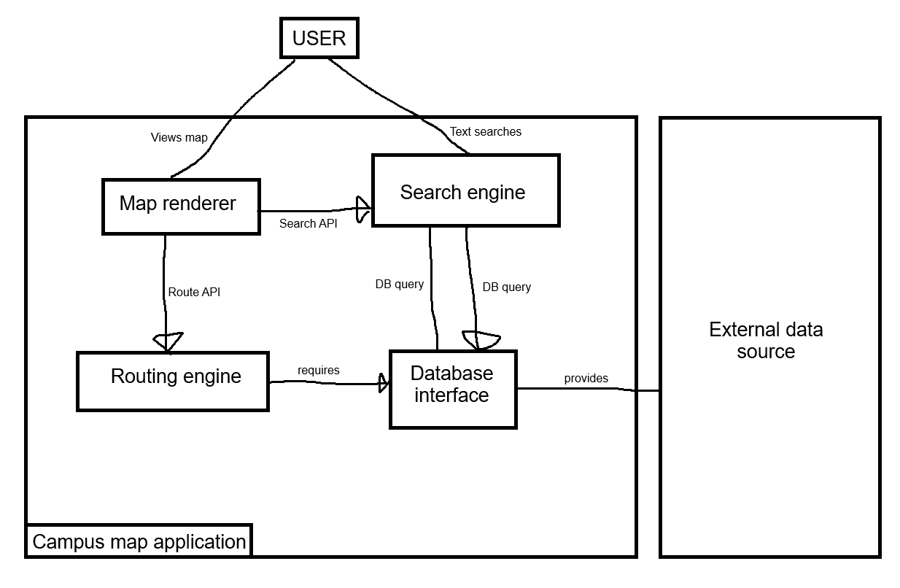

Figure 6.3 Component diagram: components, provided and required interfaces, external systems
Component | Responsibility (one sentence) | Provides | Requires | Answers to (UC / QAS / ADR)
Map renderer | Manages client viewport and user interactions | Map display | Route API, Search API | UC-01, UC-02, UC-03 UC-04, QAS-02, ADR-01
Search engine | Provides user with data based on an inputted query | Search API | DB Query | UC-01, UC-03, QAS-01, ADR-01
Routing engine | Calculates optimal route between locations | Route API | DB Query | UC-02, QAS-01
Database interface | Retrieves data from external data source | DB Query | None | UC-04

6.4 Deployment view
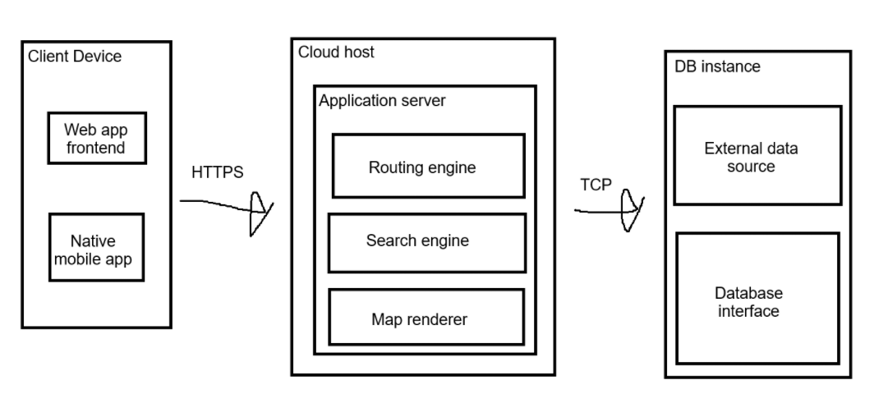

Figure 6.4 UML deployment diagram: nodes, execution environments, deployed artifacts, communication paths with protocols, trust boundaries
Node | What runs on it (artifacts,  components) | Communicates with  (protocol) | Trust zone
Client device | Web browser/mobile app | HTTPS | Public internet (untrustworthy)
Could host | Routing engine, search engine, map renderer | TCP | Secure application
DB Instance | External data source, DB interface | Cloud application server | Private database (full trust)

6.5 From analysis to architecture
Analysis object (from 5.1 and 5.2) | Component that owns it (6.3) | Note (split, merged, external)
CampusMap, Location, Category | Database interface | Merged into DB
SearchQuery, CategoryFilter | Search Engine | Split between client input and backend processing
RouteRequest, WalkingRoute, RouteWaypoint | Route Engine | Internal route calculation and waypoint coordinates are external
SearchCoordinator | Search Engine | Split between client input and backend processing

6.6 Design principles applied
Principle | Where it shows in your design | Evidence (component,  interface, ADR)
Separation of concerns | Splitting map rendering from routing and search logic | Map rendering UI vs. Search and Routing engine
Information hiding | Database is hidden behind a data interface | Data interface providing DBQuery interface
Low coupling | Independent backend services | SearchAPI and RouteAPI
High cohesion | Backend services focus on one task | Search engine and routing engine
Design for change | Isolated external data | External data source
Keep it simple (KISS) | Lightweight single page web application | ADR-01

